# **Stream Created Embed**

**Plain text before embed:** <@ID for stream officer> <@user> (user here is the model selected)

**Author:** Tag user who used command (can be admin or model)

**Author Icon URL:** Profile picture of the user above

**Thumbnail URL:** Server icon  
**Title**: ✦ Stream Tracker Log ✦

**Description**:

A new stream has been registered. Details are below—please follow the workflow until the due date.✦

**Model**: <@{option_user_id}>

**Items**: {option_items}

**Due**: <t:{BGVAR_due_unix}:D> in {option_due_days} days  
**Creator:** (Tag creator)

**Stream ID:** (10 Randomly generated characters, unique)

**Footer**: ❖ Even the stars follow patterns of order. ❖ - Astraee | Created: (unix to iso time now)  
  
Example: 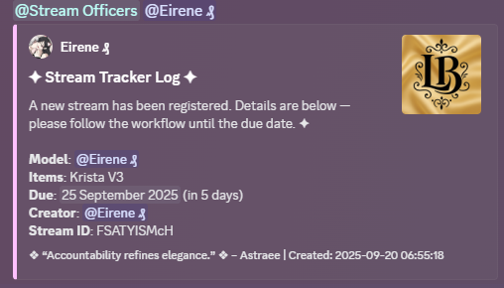

# **Stream Created DM (Sent to User's DMs)**

(Can be a regular message as before. See example.)

**Title**: ✦ Greetings, radiant star! ✦

**Description**:

Your L&B stream has been created. Retain these details for your records and use them with /completestream when complete:

* **Stream ID**: {stream_id}
* **Items**: {items}
* **Due Date**: <t:{due_unix}:D>

**Next Step:** When your stream is complete, use /completestream stream_id:{stream_id} to mark it done.

Keep this ID safe—your brilliance guides the cosmos!

**Footer**: ❖ The stars shine brightest with your care. ❖- Astraee | Created: <t:{time.now_unix}:D>

Example: 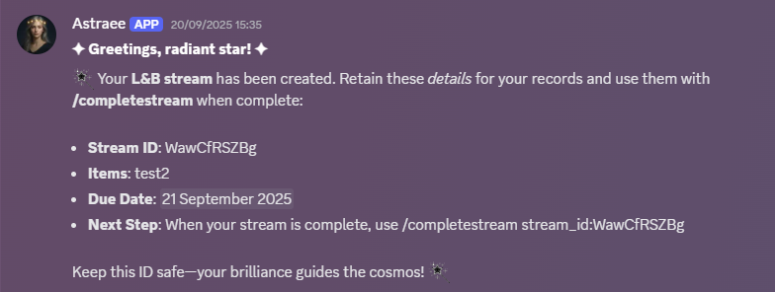

# **No Active Streams Embed (Reply to Command when no active streams)**

**Title**: ✦ Active Streams Overview ✦

**Description**:

There are currently no active streams in the constellation. Check back when new collaborations align.

**Footer**: ❖ Even the stars rest in quiet moments. ❖ - Astraee | At: {time_now_unix}

# **Active Streams Embed (Reply to Command)**

**Author:** Server name

**Thumbnail URL:** Server icon

**Title**: ✦ Active Streams Constellation ✦

**Description**:

Behold the current alignments:

{active_list}

Nurture these collaborations with grace.

**Footer**: ❖ The stars align for those who dare to dream. ❖ - Astraee | Total Streams: {num_streams}

**Time variable:** {time_now_unix}

Example: 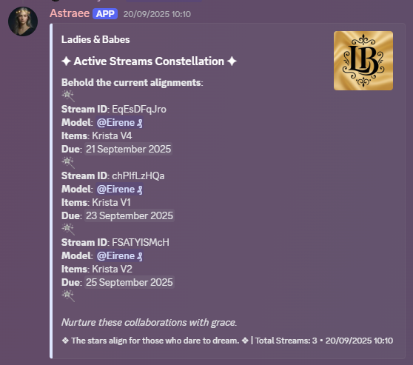

# **Stream Complete Embed (Posted to #stream-tracker Channel)**

**Author:** Server name

**Thumbnail URL:** Server icon

**Plain Text: <**@Stream officer role ID>

**Title**: ✦ Stream Completion Log ✦

**Description**:

**A stream has reached its harmonious end. Details below**:

**Model:** <@{complete_user}>

**Items:** {complete_items}

**Original Due:** <t:{complete_due}:D>

Well done—your light shines brighter.

**Footer**: ❖ Grace in action reflects the harmony within. ❖ - Astraee | Stream ID: {stream_id} | Completed: <t:{time.now_unix}:F>

Example: 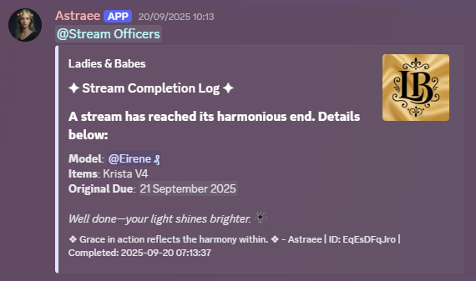

# **Stream Not Found Embed (Reply to Command)**

**Title**: ✦ Stream Not Found ✦

**Description**:

No alignment matches that ID. Verify and try again.

**Footer**: ❖ Patience is the finest art. ❖ - Astraee

# **Stream Reminder Embed (Posted to #stream-tracker Channel)**

**Title**: ✦ Stream Reminders: Alignments Approaching ✦

**Description**:

Celestial alert: These streams draw near their zenith. Nurture them before the stars shift.

{reminder_list}

**Footer**: ❖ Even the stars whisper of time's gentle pull. ❖ - Astraee | {time.now}

Example: 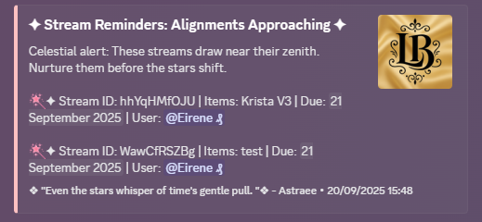

# **Stream Reminder DM Embed (Sent to User's DMs)**

**Title**: ✦ Stream Reminder ✦

**Description**:

Radiant one, your stream {stream_id} approaches its due: <t:{due_unix}:D>. Items: {items}. Complete with /completestream when ready.

**Footer**: ❖ Grace awaits your light. ❖ - Astraee

# Note:

Replace all variables and fields accordingly. You may edit and refine as you see appropriate. This is just a reference of the old.